WHERE WE’RE LOCATED
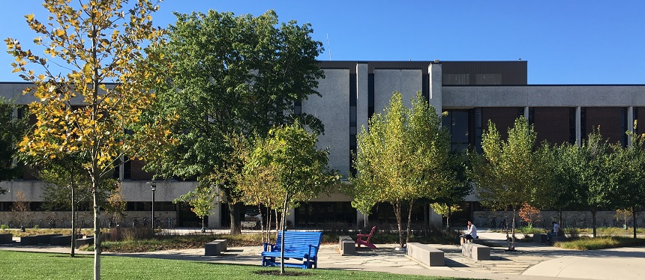
Robinson Hall – Rowan University Main Glassboro Campus

In order to reach our lab at Robinson Hall, you will have to park nearby in parking lot O-1. If you search for “Rowan University Lot O-1,” this parking lot should appear. You can also use the following link to find this location in google maps: https://goo.gl/maps/JgSUAwue5Jn4LsxW6

DIRECTIONS TO ROWAN UNIVERSITY FROM OUTSIDE OF GLASSBORO

From the North (Northern New Jersey, New York, etc.)
- Take the NJ Turnpike South to Exit 4 (73 North).
- In approximately 1 mile, take I-295 South.
- Follow I-295 to Route 42 South (Atlantic City).
- Exit Route 42 South onto Route 55 South.
- Follow Rte. 55 South to exit 50A (Glassboro-Mullica Hill).
- You will reach a traffic light immediately after exiting Route 55. Go straight at this light to take Route 322 East until you reach the next traffic light (Joseph L Bowe Blvd.).
- Make a left turn onto Joseph L Bowe Blvd., followed by a right turn onto Stadium Dr. (across the street from Glassboro High School).
- Continue on Stadium Dr. and follow signs to parking lot O-1.

From Philadelphia
- Take the Walt Whitman or Benjamin Franklin Bridge to I–676 South toward Atlantic City.
- Shortly after I–676 becomes Route 42 South, exit right onto Route 55 South.
- Take Rte. 55 South to exit 50A (Glassboro–Mullica Hill).
- You will reach a traffic light immediately after exiting Route 55. Go straight at this light to take Route 322 East until you reach the next traffic light (Joseph L Bowe Blvd.).
- Make a left turn onto Joseph L Bowe Blvd., followed by a right turn onto Stadium Dr. (across the street from Glassboro High School).
- Continue on Stadium Dr. and follow signs to parking lot O-1.

From the West
- Take I–95 to the Commodore Barry Bridge.
- Follow Route 322 East (15 miles) to the campus.
- You will eventually reach a traffic light at which you can either go straight, turn right onto Harvard Rd., or turn left onto Joseph L Bowe Blvd.
- Make a left turn onto Joseph L Bowe Blvd., followed by a right turn onto Stadium Dr. (across the street from Glassboro High School).
- Continue Stadium Dr. and follow signs to parking lot O-1.

From Central New Jersey
- Take Route 70 West to I–295 South.
- Follow I–295 to Route 42 South (Atlantic City).
- Exit Route 42 South onto Route 55 South.
- Follow Route 55 South to exit 50A (Glassboro–Mullica Hill).
- You will reach a traffic light immediately after exiting Route 55. Go straight at this light to take Route 322 East until you reach the next traffic light (Joseph L Bowe Blvd.).
- Make a left turn onto Joseph L Bowe Blvd., followed by a right turn onto Stadium Dr. (across the street from Glassboro High School).
- Continue on Stadium Dr. and follow signs to parking lot O-1.

From the East
- Take the Garden State Parkway to the Atlantic City Expressway.
- Take the Expressway West to Exit 38 (Williamstown).
- Turn left after exiting and follow Route 322 West (8 miles) to the campus.
- After the roundabout on Rowan Blvd, continue straight through the next traffic light (Memorial Circle) then make a right turn onto Joseph L Bowe Blvd. at the following traffic light.
- After turning onto Joseph L Bowe Blvd., make a right turn onto Stadium Dr. (across the street from Glassboro High School).
- Continue on Stadium Dr. and follow signs to parking lot O-1.

From the South (Maryland, Delaware, etc.)
- Take I–95 North to the Delaware Memorial Bridge.
- Take the N.J. Turnpike North to Exit 2 and take Route 322 East.
- Stay on Rt. 322 for approximately 14 miles.
- You will eventually reach a traffic light at which you can either go straight, turn right onto Harvard Rd., or turn left onto Joseph L Bowe Blvd.
- Make a left turn onto Joseph L Bowe Blvd., followed by a right turn onto Stadium Dr. (across the street from Glassboro High School).
- Continue Stadium Dr. and follow signs to parking lot O-1.

After parking in lot O-1, a study team member will escort you to our lab in Robinson Hall.

